≪To All Users≫
Please adhere to the following rules at Nanakuni Park Dog Run in order to keep and deepen mutual understanding between neighborhood residents and Dog Run users as well as to promote dog lovers’ good manners.
【Nanakuni Park Dog Run Rules & Regulations】

※Only registered users may enter. (Except for park officials and those who are permitted by officials.)
※All users are responsible for any accidents, injuries, or troubles occurred in the facility.
※If you are involved in any accidents or troubles with other users, you must negotiate with the party on your own responsibility. Hachioji city and the Management Office are not responsible. However, you are asked to report the incident to the Management Office. (Written report may be required.)
- All users must adhere to Rabies Prevention Law, metropolitan regulations about animal welfare and management, municipal park regulations, and other rules and regulations applicable.

- Qualifications
（１）Who can use the dog run
  - Only registration certificate holders may use the facility.
  - The registration certificate will be issued to those who attend the user registration briefing and agreed to follow the facility rules and regulations.
  - Preschool children are not allowed in the dog run. Children under 16 years old may use the facility with a registered parent/ guardian.
  - The registration certificate is valid for a year. If you wish to continue your user status, renewal is required within its expiration date.
※Those who are unable to manage dogs may not use the facility by own.
User Categories
 | Registration | Parent/Guardian | Others
Preschoolers | Not Allowed |  | N/A
Under 16 | Necessary | Necessary | An accompanying parent/guardian also needs to be registered.
16 + | Necessary | Unnecessary

Dogs
  - Owners should have their dogs registered accordingly to Rabies Prevention Law and make sure they are wearing the registration tags.
  - Owners are obliged to have their dog inoculated against rabies once every year and make sure they are wearing the inoculation tags.
  - It is desirable for owners to have their dogs vaccinated with Five or more in 1 vaccine more than once in the past three years.
  - Dogs should be free of flea, tick, lice and other ectoparasites, and internal worm, filarial and other endoparasites. They also should be free of any infectious diseases.
  - Female dogs in heat (during and after 4 weeks of proestrus bleeding) should refrain from using the facility.
- Hours
- 9:00-17:00 (9:00-16:00 during winter: from November to March)
- The facility will be closed for a few days during summer and on New Year days. Check online for the specific dates.
- The facility may be closed under severe weather and necessity of maintenance without any previous notices.
- The facility is closed to be maintained during the registration renewal term.

- Areas
- Small breed dog area is only for small sized dogs on JKC classifications.
- Medium and large breed dog area is only for Medium and large sized dog on JKC classifications.
- Mixed breed dogs weigh less than 6kg (13.2277lbs) should use Small breed dog area. If the weight exceeds 6kg, go to medium and large breed dog area.
- Admissions may be restricted when the facility is overwhelmed.
※JKC classifications are defined by Japan Kennel Club.

- Withdrawal
（１）Return your registration certificate when you no longer wish to use the facility due to moving out from Hachioji city or other reasons.
（２）Your registration status may be terminated when
①you do not follow above rules and regulations.
②you offend public nuisance.

- Your personal information is only used for our services.

- Obey the Rules and regulations
（１）Prohibited Uses
- Entrance of dogs that may disturb other people and dogs.
- Feeding inside of the facility.
- Use of Strollers and dog buggies.
- Freeing dogs with their leashes on.
- Smoking, eating and drinking.
- Reading and napping. Voluntary bringing chairs and picnic sheets.
- Playing with balls, frying disks and other toys.
- Disposing any fecal matters into a lavatory or discharging them at any places around the facility.
- Unleashing dogs in between the double entry doors.
- Grooming.
- Taking any other animals than dogs.
- Engaging in any commercial activities or commercial speeches.

- Rules
- Always have your registration certificate around your neck. You shall not enter the facility without the certificate.
- Do not provide false information upon registration. Your user status shall be terminated when misrepresentations are found. Please notify us of any updates to your registered information.
- Record your registration numbers and entrance/exit time on the usage note.
- Pick up after your dogs and water where they urinated.
- Always put a collar on your dog and have your dog under your control in the facility. Do not unleash your dogs while they are upset with the environment.
- Control destructive behaviors of your dogs; such as chasing after, barking at, and mounting on other dogs.
- Do not open the entrance double doors at the same time. Exiting folks go first. (To prevent dogs from running out.)
- Clean after yourself. (No trash box is available in the facility.)
- Number of dogs you can bring with you is limited to 2 for small/medium breed dogs (under 16kg: 35.2739619 lb for mixed breed dogs) and 1 for large breed dogs (over 16kg for mixed breed dogs).
- Park your car in the designated parking lot. Do not park illegally on streets or neighborhood areas of the park.
- Follow the instructions by official volunteers of the facility.
- Adhere to and obey the metropolitan regulations about animal welfare and management.
- The management office is not responsible of any diseases and infections transmitted in the facility.
- Ask for permissions when taking photos of dogs other than yours.
- Do not occupy the facility with a large group. (Group meetups are prohibited.)
- Do not extend reel leashes in the dog run and other areas of Nanakuni Park. Always have your dogs under your control.
- The office does not intervene in bite accidents; however, you must report the details, circumstances, and settlements of the incident when it unfortunately happens.
Supplementary Provisions
This rules and regulations are enforced on June 1st, 2008.
A partial amendment was made on October 1st, 2009.
A partial amendment was made on July 1st, 2011.

- All accidents and troubles should be negotiated to a settlement between the parties who are involved. All users should take own responsibilities for any accidents and injuries occur in the facility.
The management office and the city of Hachioji are not responsible for any diseases, dermatosis, ectoparasites, and endoparasites transmissions occur in the facility.
（Do not make a claim for damages against the city of Hachioji or the management office.）

Bite Accident
Based on “the metropolitan regulations about animal welfare and management”, follow the following rules.
◆ Contact Information
Designated Administrator  South Western Area Yumeori Park |  | 042-649-8900
Health Center | Hachioji | 042-645-5111
 | Machida | 042-722-0621
 | Sagamihara | 042-769-8347
Hachioji Fire Department |  | 042-625-0119
Metropolitan Animal Protection Center Tama Branch Office |  | 042-581-7435
Police Station | Minamiosawa  （Local station of Nanakuni） | 042-653-0110
 | Hachioji | 042-645-0110
 | Takao | 042-665-0110
 | Machida | 042-722-0110
 | Sagamihara | 042-754-0110
  - When a dog bites a human
    - The owner should take an immediate action to prevent another bite and report the case to Hachioji Health Center within 24 hours.
    - The owner must have the dog examined against rabies within 48 hours.
    - Report the case to the management office.
  - When a dog bites another dog
    - The case should be negotiated between the owners who are involved.
    - Report the case to the management office.
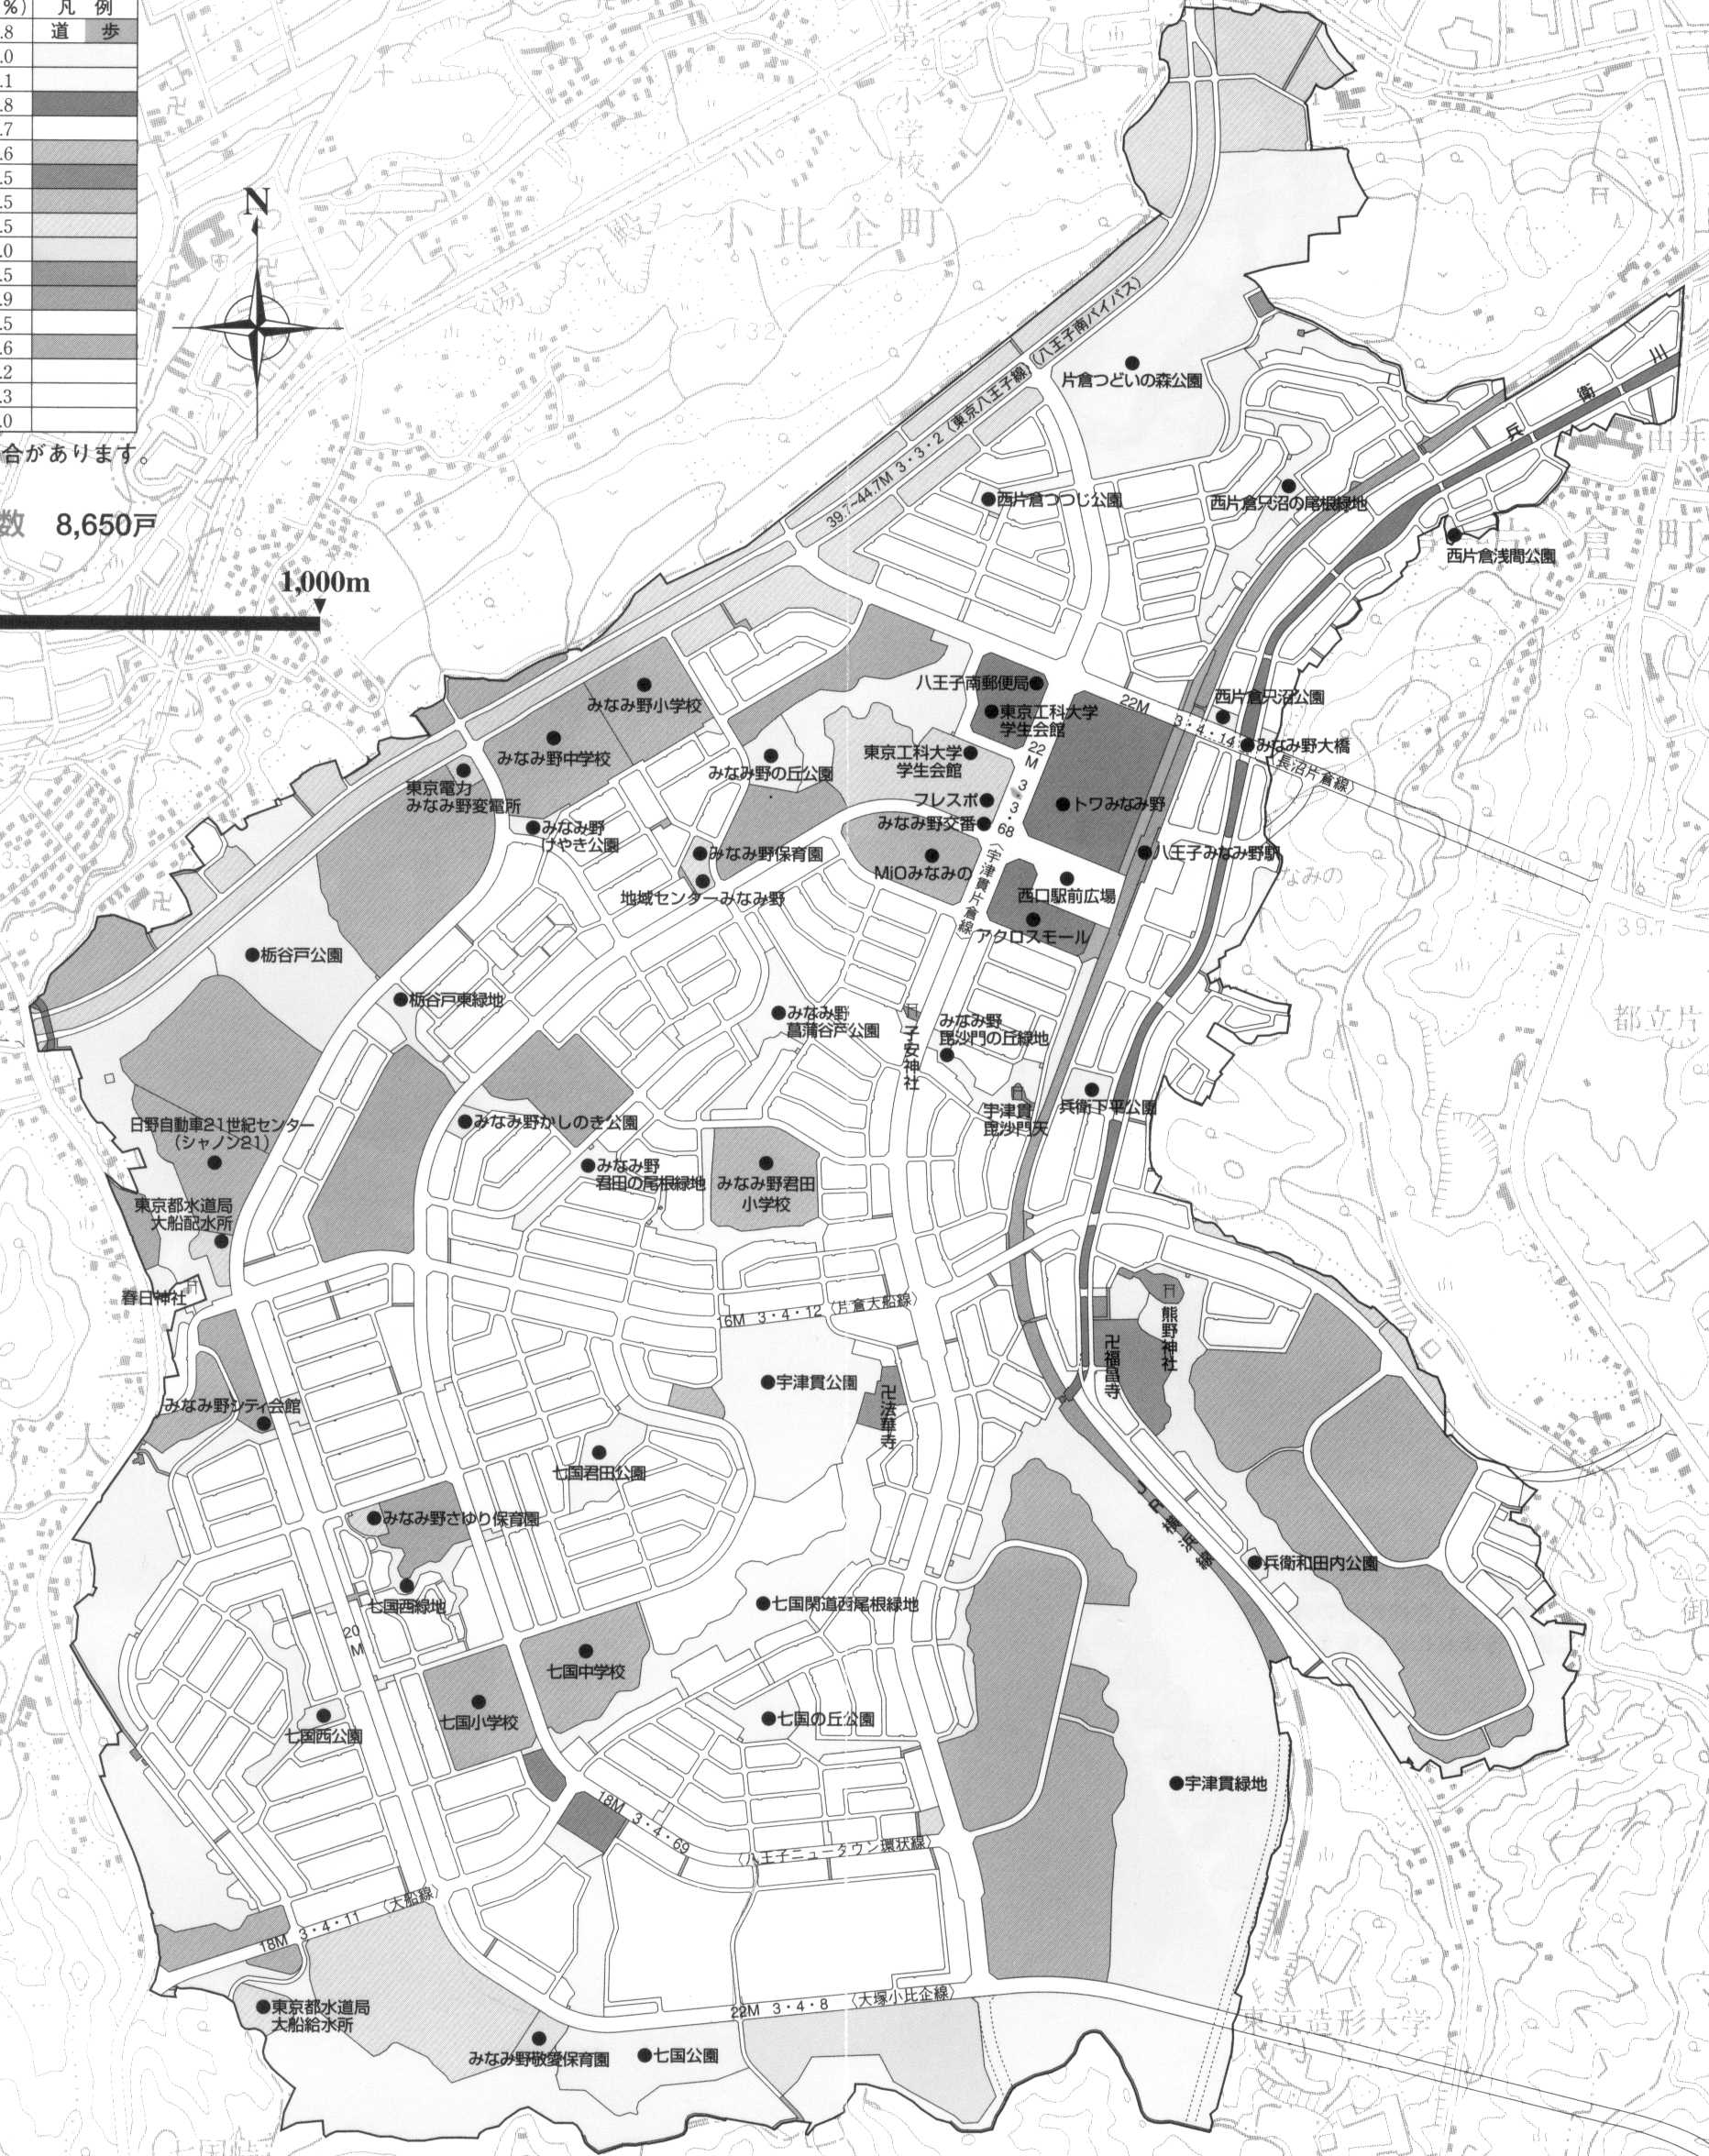
    - Report it to Hachioji Health Center /Metropolitan Animal Protection Center and the local police station. Medium and large breed dogs might manage to leave the area; therefore, report it to the neighborhood police stations and health centers.
Hachioji New Town
Nanakuni 2chome Bus stop
[Published by]
Hachioji City Office
Park Section
Designated Administrator of South Western Hachioji City Park
South Western Area Yumeori Park
Phone: ０４２.６４９.８９００

Dog Run Management Office
Phone：０４２.６３７.７５６９

●ホーマック
●ホーマック

